**Integrated Systems Modeling of the Interactions between Stationary Hydrogen, Vehicle, and Grid Resources**

**GM0229**

**Date: January 16, 2017**

*Lab PI: Samveg Saxena (LBNL), 510-269-7260, SSaxena@lbl.gov*

*Lab+1: Joshua Eichman (NREL), Joshua.Eichman@nrel.gov*

*Additional Project participants (Labs + partners): INL, NREL, LBNL*

*DOE Technology Development Managers (for both OE and EERE): David Peterson (EERE/FCTO), 240-562-1747,* david.peterson@ee.doe.gov

*GMLC Technical Topic Lead: John Grosh, grosh1@llnl.gov*

*Project Start Date:* June 1, 2016

*Project End Date:* May 30, 2019

1. **Project Description**

The goal of this multi-year project is to establish the available capacity, value, and impacts of interconnecting hydrogen infrastructure and fuel cell electric vehicles to the electric grid.  The first objective is to quantify the opportunity of utilizing flexibility from hydrogen systems to support the grid.  This directly addresses Task 2.1.3 of the grid modernization multi-year program plan and includes provision for vehicle and station controllable loads.  Additionally, the methodology and results of this project can support understanding of available grid services and their optimal implementation as it relates to hydrogen systems (Tasks 2.2.6-10).

The second objective is to develop and implement methods to assess optimal system configuration and operating strategy for grid-integrated hydrogen systems.  This involves developing a modeling framework that can analyze the value of optimally dispatching resources based on grid needs, while respecting hydrogen production and vehicle travel requirements. Tasks 2.3.1-5 of the program plan demonstrates the importance of open and accessible model development.  There are a number of emerging use cases for hydrogen systems that this work will expand upon (tasks 2.4.1-4).  Delineating these use cases is of particular importance since hydrogen production spans a variety of energy sectors. Implementation of a front end controller highlights the contribution to device specification and communications that this work can provide (task 2.3.8 and 3.1.2).  Lastly, a broad range of data products are needed to assess the capability and value for grid integration of hydrogen systems.  These include equipment costs, market data, vehicle operation and fueling data, to name a few.  The collection and availability of this data is important to further enable the technology.  Some of the data will be available for release to help establish a benchmark for future work, thus the collected data supports tasks 5.3.3-4.

Success of this project after three years is measured by the development and integration of a set of models to assess the opportunity for hydrogen grid integration.  This includes development of new models and controllers and leveraging existing models to understand the capacity of available hydrogen infrastructure to provide grid support and to understand the value stemming from that support.

1. **Total Planned Funding (for entire project)**

|  |  |  |  |  |
| --- | --- | --- | --- | --- |
| **Entity** | **Funding Planned by Fiscal Year** | | | **Total** |
| **FY16** | **FY17** | **FY18** |
| LBNL | $250,000 | $300,000 | $300,000 | $850,000 |
| INL | $50,000 | $50,000 | $50,000 | $150,000 |
| NREL | $200,000 | $200,000 | $200,000 | $600,000 |

1. **Summary of Activities in This Quarter by Task and Lead Lab(s) per Task (Accomplishments/Highlights, worthy of communications)**

Quarterly objective: Realistic integration of H2 resources into grid models to capture potential benefits and impacts for H2 technologies.

* 1. **Refine the refueling behavior model in H2VGI using the real-world data from NREL.**

In our previous work, the refueling behavior is modeled as a linear function of the vehicle state of energy (SOE), as shown in Fig. 1. We assume that a FCEV driver first considers stopping at a hydrogen refueling station when the SOE reaches 50%. As the SOE decreases, the probability of the driver stopping to refuel increases linearly, with the probability of a driver stopping to refuel approaching 1 as the SOE approaches 0%. We assume that a FCEV will get fully refueled when stopping at a hydrogen refueling station.



Figure 1. FCEV refueling behavior assumption in our previous work.

In this quarter, the LBNL team obtained the real-world refueling data from NREL, as shown in Fig. 2 and Fig. 3. Fig. 2 illustrates the distribution of tank level at fill. It can be seen that refueling may happen when the tank level is lower than 75% in the realistic case. The median tank level at fill is 29%. Fig. 3 shows the distribution of refueling amounts for FCEVs. It indicates that 37% of vehicles get less than 1kg hydrogen and 40% of vehicles get 1kg – 2kg hydrogen at stations. The refueling behavior model in H2VGI has been refined based on this real-world data.

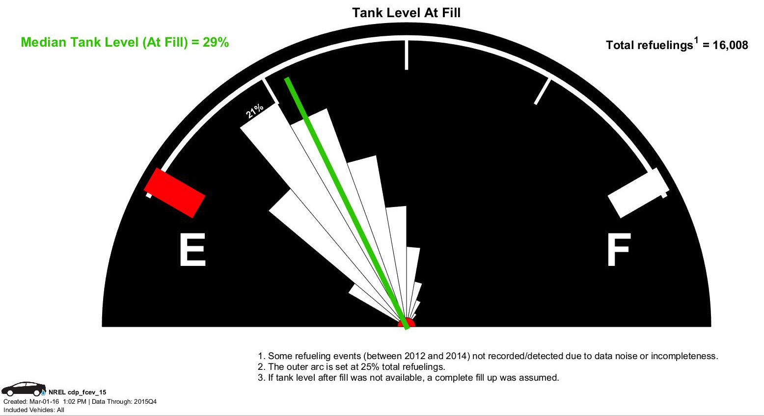

Figure.2. FCEV tank level at fill

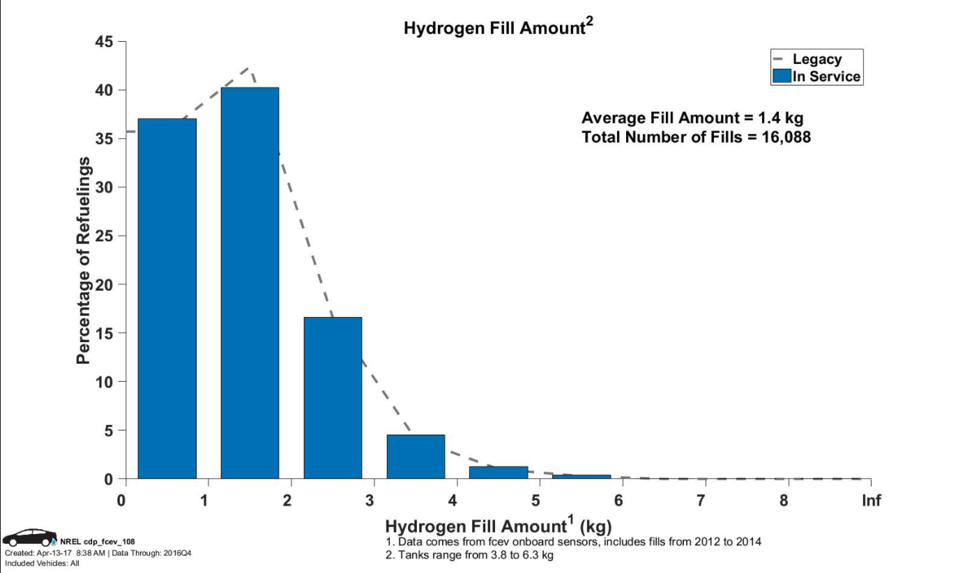

Figure. 3 Distribution of hydrogen fill amount.

We then simulate the cumulative hydrogen demand at a refueling station which serves 2000 FCEVs based on different refueling models. Fig 4. shows that even though the FCEVs have the same travel itineraries in these two cases, different assumptions on refueling behavior cause a difference in the hydrogen demand at the refueling station. The more realistic refueling model allows us to have a better formulation on individual vehicle constraints, which is important in flexible resource optimization problems.



Figure. 4. Cumulative hydrogen demand of 2000 FCEVs at a refueling station.

* 1. **Establish the conceptual model to integrate H2 resources in PLEXOS.**

In order to quantify the impacts and benefits of the flexibility from hydrogen systems, we incorporate hydrogen resource modules (e.g., electrolytic hydrogen generation, fuel cells, etc.) in a PLEXOS production cost model. “PLEXOS” is tried-and-true simulation software that uses state-of-the-art mathematical optimization combined with the latest data handling and visualization and distributed computing methods, to provide a high-performance, robust simulation system for electric power, water and gas. PLEXOS can be used to help the designers to get a least cost system. For example, the flexible load can be rearranged based on the constraints to smooth the “duck curve” as much as possible according to the optimization object.

In this quarter, the team developed a modeling methodology for representing the operation of electrolyzers within a production cost model, that includes the physical characteristics and operational constraints of hydrogen stations. In this model, the hydrogen generation load is added to explore the influence on the system, such as the total generation cost, generator start and down cost comparison.

When we choose a PLEXOS object to model the hydrogen production system, three requirements should be considered. First, hydrogen production load is flexible. As long as the station has enough hydrogen to supply FCEV demand, the electrolysis load can be shifted around. Second, the PLEXOS object should be able to model the hydrogen storage limitation. Third, the PLEXOS object should be able to represent both energy consumption and generation, so that H2G scenario can also be modeled.

Therefore, we use pumped-storage hydroelectric (PSH) power stations to model hydrogen production and storage devices. A PSH station has two operation modes: (1) generation mode that allows water to flow from the head reservoir to the tail reservoir, and (2) pumping mode that consumes electricity to move water uphill from the tail reservoir to the head reservoir.

As shown in Fig. 5, we represent the following features of an electrolyzer using the PSH station model in PLEXOS. Hydrogen that is either produced by electrolysis or drawn by FCEVs is analogous to the water that the PSH generator moves from its reservoirs. In the PSH, the head reservoir is a place to store energy by keeping the water at a higher altitude. Similarly, the head reservoir in this model is a proxy for the amount of hydrogen in a station’s hydrogen storage tanks, for FCEV refueling. The hydrogen demand from FCEVs is imported from H2VGI and modeled as spilled water from the head reservoir in the PSH model in PLEXOS. It enables the system to constrain the status of the head reservoir to guarantee there is always enough hydrogen to support vehicles’ fueling demands. Specifically, we describe the analogy as follows:

* + The red arrow line represents the water is pumped from the tail reservoir to the head reservoir by consuming the electricity. This process simulates the hydrogen production by consuming the electricity.
  + Once the water is spilled to the sea from the head reservoir, the water volume in the head reservoir will decrease. Similarly, filling the FCEV hydrogen tank at hydrogen station will decrease the hydrogen storage level at hydrogen station.
  + The dash blue arrow line (H2G) represents that the water flows from the head reservoir to the tail reservoir, which is an electricity generation process. The PSH station will work in the generation mode to feed electricity back to the grid.

It should be noted that in the first step, we are only simulating the H1G case, which means the water cannot flow from head reservoir to the tail reservoir. Thus, only the H1G process is considered. However, the conceptual model has the potential to simulate H2G case as well. $P^{max}$ is the maximum power of the hydrogen production of the electrolyzer. $P^{L}$ is the hydrogen production load, which is time varying. $P^{G}$ is the power of generation by consuming hydrogen in H2G case.

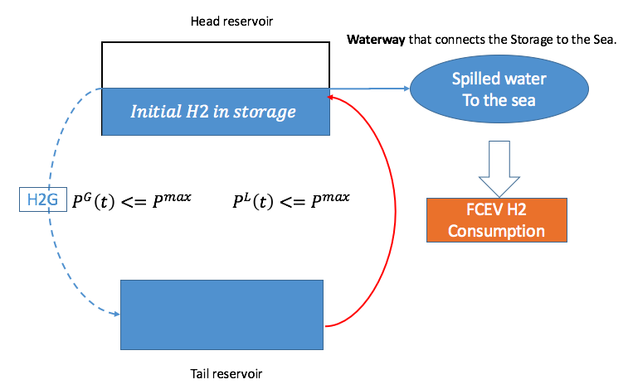

Figure. 5. Conceptual model to integrate hydrogen systems into PLEXOS as PSH stations.

**3.2.1 Simulation setup**

In this quarter, a sample five-bus power system on a day-ahead basis is adopted to explore the whole modeling process. Parameters of the five generators in the system are shown in Table 1.

Table 1: Technical parameters of the generators in the sample five-bus system

|  |  |  |  |  |  |  |  |  |
| --- | --- | --- | --- | --- | --- | --- | --- | --- |
| Generator | Max Capacity (MW) * | Min Stable Level (MW) * | Fuel Price ($/MMBTU) | Heat Rate (BTU/kWh) | Start Cost ($) | Min Up Time (h)* | Initial Generation (MW)* | Initial Hours Up (h)* |
| a | 110 | 40 | 1.2 | 15000 | 450 | 4 | 0 | 3 |
| b | 600 | 200 | 1.2 | 15000 | 450 | 4 | 400 | 3 |
| c | 100 | 40 | 1.2 | 15000 | 300 | 8 | 0 | 5 |
| d | 520 | 100 | 1.2 | 28000 | 150 | 1 | 100 | 4 |
| e | 200 | 50 | 1.2 | 40000 | 1200 | 15 | 170 | 2 |

*Max Capacity (MW): the maximum generating capacity of each generator.

*Min Stable Level (MW): the minimum stable generation level of each generator. This minimum level is enforced when the generator is turned on.

*Fuel Price($/MMBTU): an input value which present the fuel price of the generator

*Heat Rate(BTU/kWh):  represent the [power plant efficiency](https://en.wikipedia.org/wiki/Plant_efficiency" \o "Plant efficiency), which is equal to (Thermal Energy In)/(Electricity Energy Out).

*Min Up Time (hours): the minimum number of hours the unit must be 'on' in any commitment cycle.

*Initial Generation: the generator load in megawatt at the start of the first period of the simulation.

*Initial Hours Up (hours): hours the unit has already been up in the beginning.

In this case study, three scenarios are created: business-as-usual(BAU), inflexible and flexible cases. The BAU represents the basic grid system without hydrogen influence. As shown in Fig. 6-a, there is no FCEV load in BAU scenario. The system topology is shown in the diagram. The black arrow line is the energy flow direction, e.g. Line_12 represents the electricity flow from node 1 to node 2.

The “inflexible” case represents the scenario in which the electrolyzer load is added, but the load is not controllable. It means the extra load is added to the existing load and will need to be served by the existing generators in the system. As shown in Fig. 6-b, the inflexible load is allocated on the node 2.

In the “flexible” scenario, the hydrogen production load is flexible without compromising FCEV demand. For example, the hydrogen production can be scheduled based on the grid load or electricity price. In particular, the electrolyzer load can be shifted to shave the netload peak. As shown in Fig. 6-c, the flexible load on node 2 represents the flexible hydrogen production load. In the above 3 scenarios, the five-bus system model allocate the region load to five nodes (1-5) as the weight factors following: 0:0.33:0.33:0.34:1.

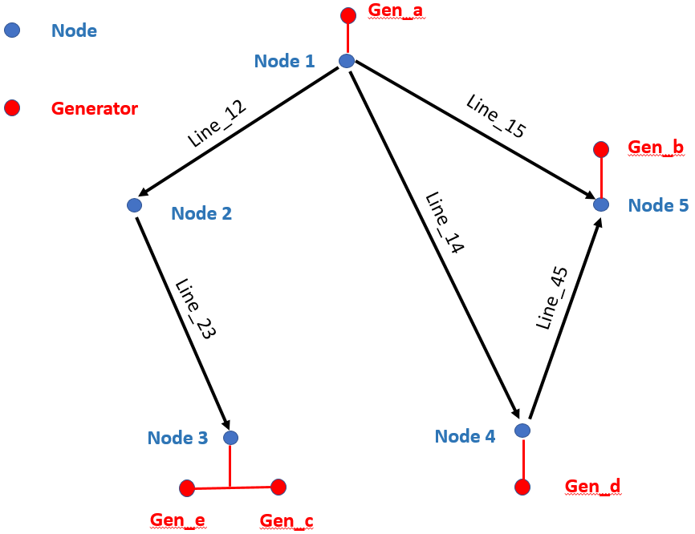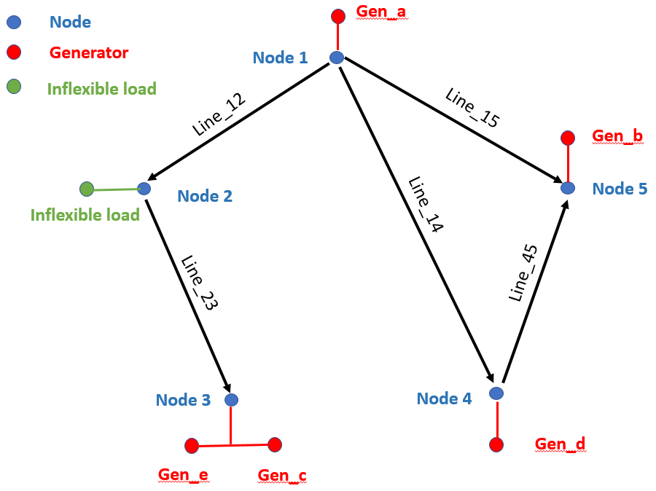

Figure 6-a. BAU scenario Figure 6-b. Inflexible scenario

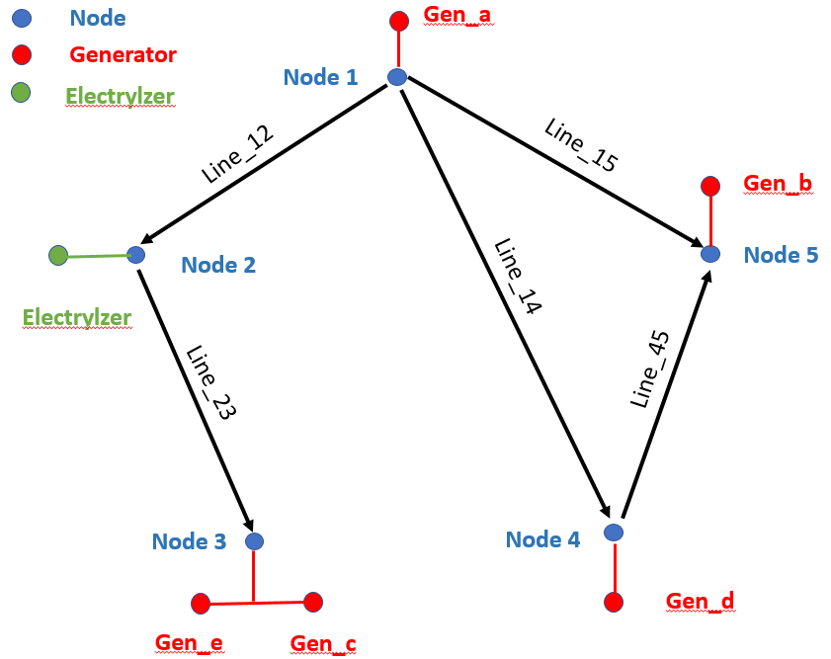

Figure 6-c. Flexible scenario

**3.2.2. Simulation results**

After running simulations, we obtained optimization and economic analysis results, such as economic dispatch results, total generation cost, generator start and down cost, locational marginal price and etc. We specifically care about the effects of adding flexibility of hydrogen production system to the original power system. We performed production cost analysis on the five-bus system and sample results of 3-day simulation are shown in Fig. 7.

As shown in Fig. 7-a, the generation cost of BAU is the lowest. After adding the inflexible load, the total generation cost increase significantly. In the “inflexible” case, the generation cost increases because the existing generators have to produce more energy and at the same time since the increased load cannot be shifted (different from the flexible case). However, when the extra load is able to be controlled (flexible scenario), the total generation cost decrease effectively.

Besides generation costs, exploiting the flexibility from hydrogen system can also reduce the shutdown cost, as shown in Fig. 7-b. The uncontrolled load results in the highest shutdown cost. The result shows that flexibility from hydrogen system can effectively reduce the generator shutdown cost.

 

Figure 7-a Generation cost ($1000) Figure 7-b Shutdown Cost ($)

Figure 7: Simulation results considering different modes of operation of the electrolyzer

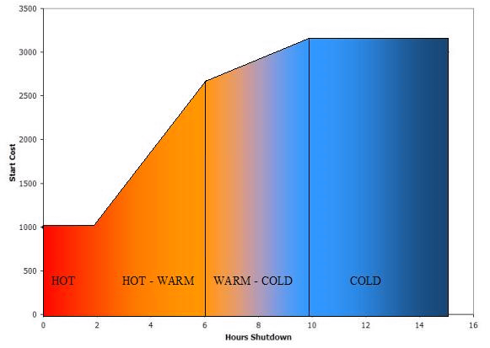

Figure 8. generator shutdown cost

Related knowledge of generator shutdown cost is shown in Fig. 8. The shutdown cost is relevant to the time. As shown in Fig. 8, the generator shutdown operation leads to a cost increase.

* 'hot' for up to two hours after being shutdown and costs $1000 to start inside the two hours;
* 'warm' for a further four hours (i.e. up to six hours after being shutdown) and costs $2500 to start at the six hour point;
* 'cold' after it has cooled for a further four hours (i.e. 10 hours in total) and costs $3000 to start at the 10 hour point.

**3.2.3 Limitations of current model**.

1. **Summary of Issues and Concerns (Technical Approach, Interoperability, Cyber, Cost schedule, Risk)**

No concerns to share at the present time.

1. **Milestone Schedule**

|  |  |  |
| --- | --- | --- |
| Milestone Description (Milestone #, Task #, Lead Lab) | Schedule –  Due date | Progress toward Completion |
|  |  |  |
| **FY2017 Past Quarter milestones** | | |
| LBNL - H2VGI model structure methodology outlined and code developed including submodel data-exchange formats. Sub-models for vehicle activity initializer, and individual vehicle models ready for integration into overall H2VGI model. | Q1 10/1/16 -- 12/31/16 | Preliminary sub-models to predict hydrogen demand from large collections have been created. At December 2. 2016 inter-lab project meeting at LBNL, revised overall structure of H2VGI model with multi-lab partners and defined several technical potential and economic studies for prioritization. Initial modeling demonstration of H2 production optimization based on time-of-use prices. |
| NREL - Establish framework for H2VGI model structure and begin to develop submodels. Prepare sub-models for hydrogen production, and station representation as well as developing an understanding for including a large-scale hydrogen rollout. | Q1 10/1/16 -- 12/31/16 | Developed preliminary electrolyzer models and station models. Considering how to integrate all models to include feedback |
| INL - Architecture definition for the Front End Controller (FEC) | Q1 10/1/16 -- 12/31/16 | Shared preliminary definition of the architecture and internal layers of the Front End Controller from projects GM0085,  GM0086 and Dynamic Modeling and Validation of Electrolyzers in Real Time Grid Simulation |
| **FY2017 milestones** | | |
| Integration of FCEV H2 consumption sub-models from LBNL with hydrogen production and dispensing models developed by NREL.  Definition of case studies on the scale of opportunity for hydrogen vehicle-station-grid integration. | Q21/1/17-- 3/31/17 | **Status:** The team has integrated several vehicle deployment scenarios from NREL into H2 consumption sub-models from LBNL to estimate net load peak shaving and ramp mitigation from flexible H2 generation in California for 2016 and 2025. A draft journal paper on the value of hydrogen production for FCEVs in California to support renewable supply integration and mitigation of grid electricity peak power and ramping requirements is in preparation.  Preliminary results from the H2 station model developed at NREL (e.g. electricity consumption by component and component pressures) have been produced and will be used to compare various station configurations for grid support. The NREL RODeO (Revenue Operation and Device Optimization Model) tool has integrated data from the national Utility Rate Database, which allows for competitiveness calculations of grid integrated electrolyzers across the U.S.  Key case studies for FCEV-station-grid integration have been defined as described above. |
| Testing and input-output validation of fully integrated mobility and hydrogen station sub-models within H2VGI model to confirm the directions of model results change as expected with inputs that have well understood sensitivities. | Q34/1/17--6/30/17 | The team has refined the data exchange from each model and validated the directionality of the results moving from model to model. The number of vehicles and stations detailed by SERA are transferred to V2GSIM which creates vehicle consumption profiles. Those profiles are sent to hydrogen production and refueling station models (i.e., RODeO and the newly developed dynamic station model).Go/No-Go Criteria: Demonstration to DOE that H2VGI model produces results that are directionally correct based on input-output validation. Go/No Go Meeting is planned with DOE in late July 2017. |
| Initial results on first case study to quantify the scale of opportunity for hydrogen-vehicle-grid integration. Write a short report with key graphs and figures summarizing findings. | Q47/1/17--9/30/17 | The team submitted a paper to explore the opportunity for providing balancing support to the grid. This shows the potential impact that hydrogen systems can have on a large grid system. |
|  | | |
| **Upcoming FY2018 milestones** | | |
| Realistic integration of H2 resources into grid models to capture potential benefits and impacts for H2 technologies. | Q110/1/17--12/31/17 | The team has refined the refilling behavior according to the realistic data. A concept model has been established in PLEXOS to perform the economic analysis. |
| Refine input values into economic models for H2 resources from available data and literature e.g., fuel cell vehicle, electrolyzer, and fueling station costs; Garner industry feedback for project modeling strategy and results. | Q21/1/18--3/31/18 |  |
| Submit economic case study quantifying the scale of the opportunity from hydrogen-vehicle-grid integration for several utility regions in the Western Interconnect for both central and distributed electrolyzer operation and station configuration/storage sizing. | Q34/1/18-- 6/30/18 | Several utility regions in the Western Interconnect assessed with all assumptions and methods vetted, i.e., demonstration to DOE that H2VGI economic modeling case study satisfactorily quantified grid benefits of H2 VGI versus costs, with self-consistent results and where possible, validation of magnitude of results. |
| Q4 – 2018 – Draft short report on testing and validation of H2VGI economic modeling case study with key graphs and figures summarizing findings | Q47/1/18-- 9/30/18 |  |

1. **Spending Summary (Current FY)**

|  |  |  |  |  |  |  |  |
| --- | --- | --- | --- | --- | --- | --- | --- |
| Entity | FY16  Carryover  ($K) | FY17  Funds Received ($K) | FY17 Funding Authorized  ($K) | Current Quarter Spending  ($K) | YTD Spending  ($K) | Committed  ($K) | Balance Remaining  ($K) |
| LBNL |  |  |  |  |  |  |  |
| NREL |  |  |  |  |  |  |  |
| INL |  |  |  |  |  |  |  |
|  |  |  |  |  |  |  |  |

* - if subcontracted out – note Lab that handled the procurement

1. **Products Developed**

* Submitted a journal article that explores the opportunity to use electrolyzer flexibility to support grid balancing for a large grid system.
* Updated H2VGI software with new refueling behavior models.

1. **Activities Planned for the Next Quarter (90 day look ahead)**

* Publish initial results on first case study to quantify the scale of opportunity for hydrogen-vehicle-grid integration.
* Performing economic assessment of hydrogen systems. This will address the benefits and shortcomings between different hydrogen system configurations (e.g., on-site vs. centralized production).
* Refine input values into economic models for H2 resources from available data and literature e.g., fuel cell vehicle, electrolyzer, and fueling station costs;
* Garner industry feedback for project modeling strategy and results.

1. **Inter-project Relationships/Coordination**

This project is being coordinated with TV031 (Dynamic Modeling and Validation of Electrolyzers in Real Time Grid Simulation), and other projects funded by FCTO under the GMLC lab call.